Import Data using Transform Maps (Spreadsheet)
Phase 3: Project Design Phase

1. Overview
The project follows a clear data flow: Spreadsheet → Import Set → Transform Map → Employee Test Table → Reports → Dashboard.
The Employee Test table is designed as the target table. It contains Employee ID, Employee Name, Email, Department and Location. The Employee Import table is used as the staging area. The Sample Spreadsheet Import Transform Map connects the source and target tables and maps the required fields.

2. Key Activities
- Target table: Employee Test.
- Target name: u_employee_test.
- Import Set: Employee Import.
- Transform Map: Sample Spreadsheet Import.
- Employee ID – String.
- Employee Name – String.
- Email – String.
- Department – String.
- Location – String.
3. Detailed Process
In this phase, the project work related to **Project Design Phase** is carried out according to the overall ServiceNow project workflow. The activities are recorded in sequence so that the implementation can be understood and demonstrated clearly.

4. Expected Outcome
The phase should produce a clear and documented output that can be verified before moving to the next phase. The project remains focused on importing spreadsheet employee data into ServiceNow using Import Sets and Transform Maps.

5. Project Evidence / Screenshots
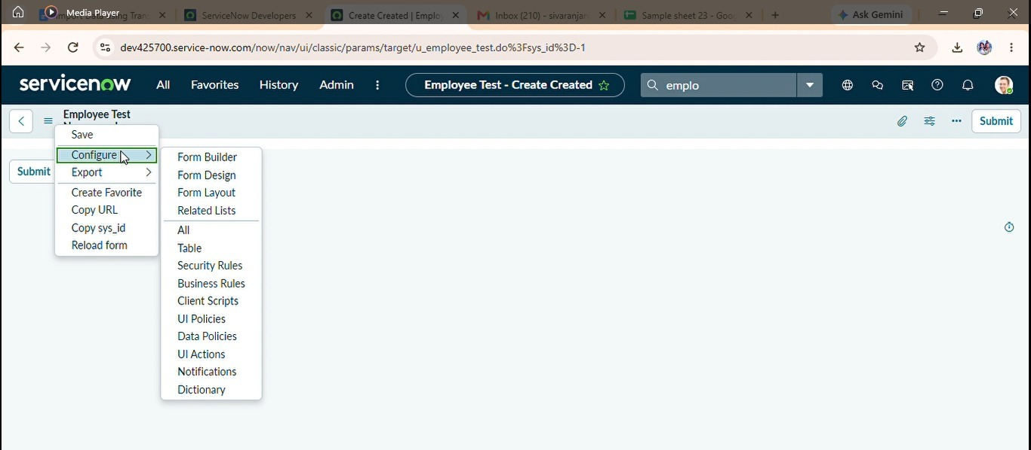

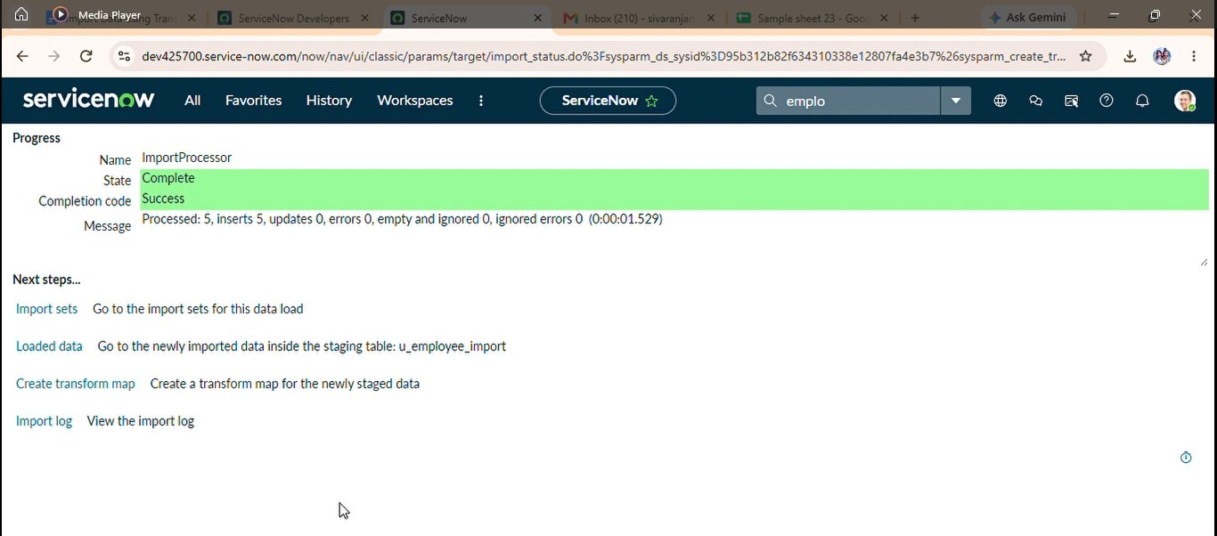

6. Phase Summary
Phase 3 completes the activities required for Project Design Phase. The documented output and screenshots provide evidence of the project work and support the transition to the next phase.

